STAGING
- Login as root user:
Query:
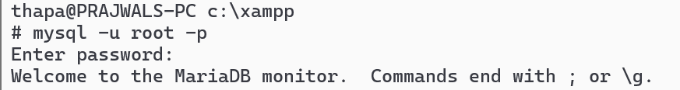

2.Check all possible privileges
a. SHOW PRIVILEGES
Query:

3.List Existing Users of Mysql DBMS:
- SELECT USER, HOST FROM mysql.user;
Query:
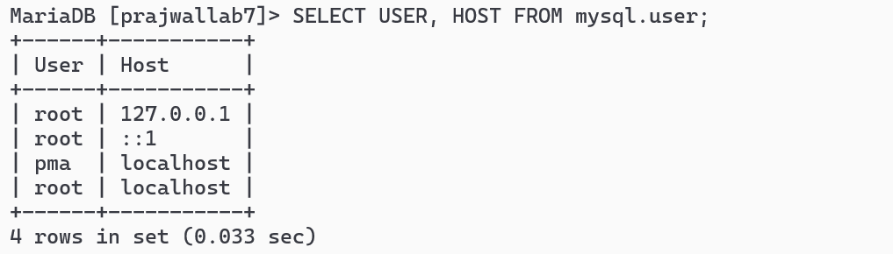

4.Check privileges of existing user as:
a.SHOW GRANTS FOR '<user>'@'localhost';
Query:

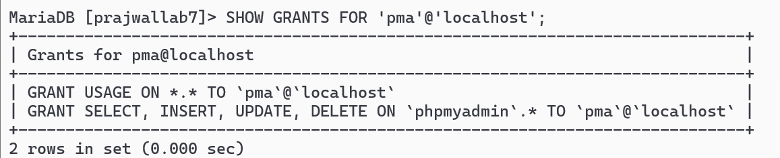
SETUP
1.List all existing Database:
Query:
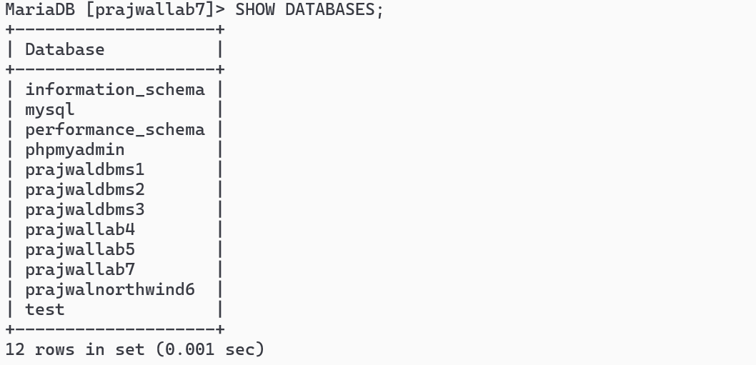
- Create a database <your-name>:
Query:

3.Create a user <your-name> i.e. Prajwal
a.CREATE USER Prajwal@localhost IDENTIFIED BY ‘P@ssw0rd’
Query:
4.Exit current session:
Query:
5.Login as newly created user i.e. <yourname>:
Query:
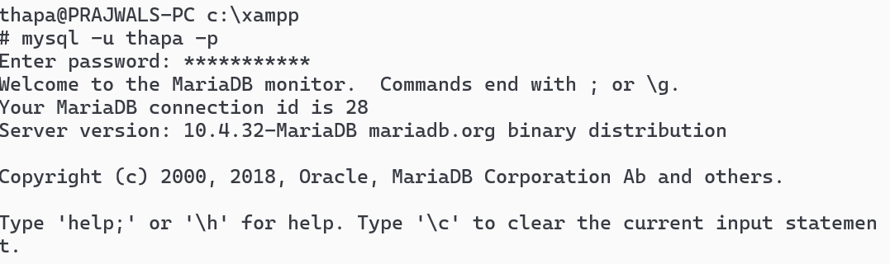
6. Check databases and exit:
Query:
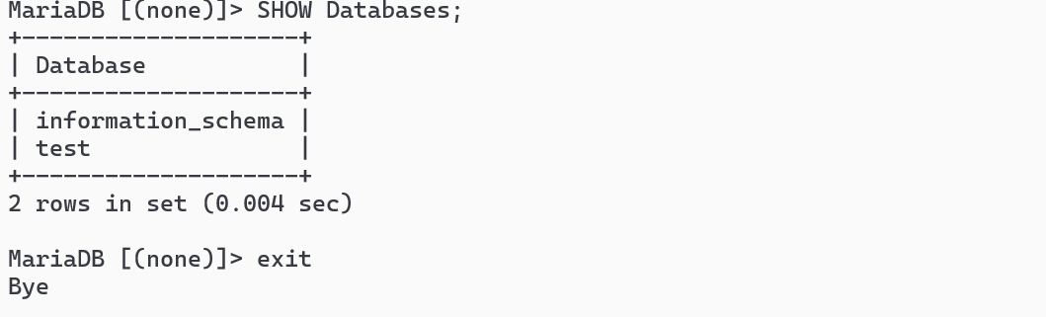

Grant

2. GRANT Privileges to user <yourname> to existing databases and exit
a. GRANT SELECT, INSERT, UPDATE ON thapa.* TO 'thapa'@'localhost';
Query:
b.GRANT ALL PRIVILEGES ON prajwal.* To thapa@localhost:
Query:
3.Login as <yourname> user:
Query:
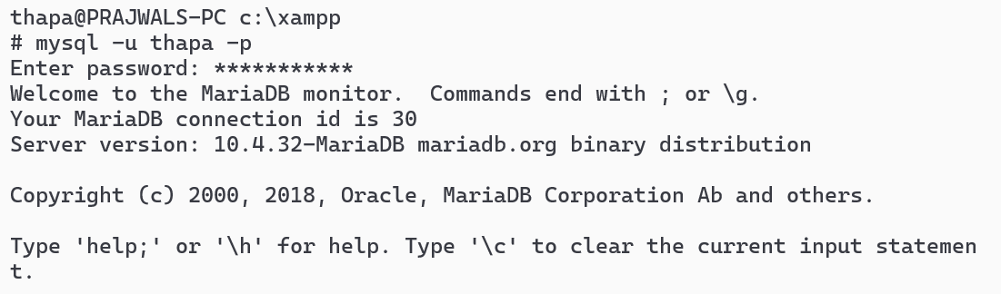
4.Use database, CREATE table tb1(id,name):
Query:
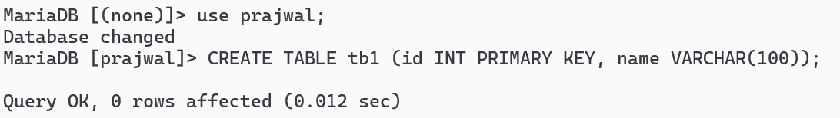

5. INSERT 2 records, UPDATE 1 record, Delete 1 RECORD:
Query:

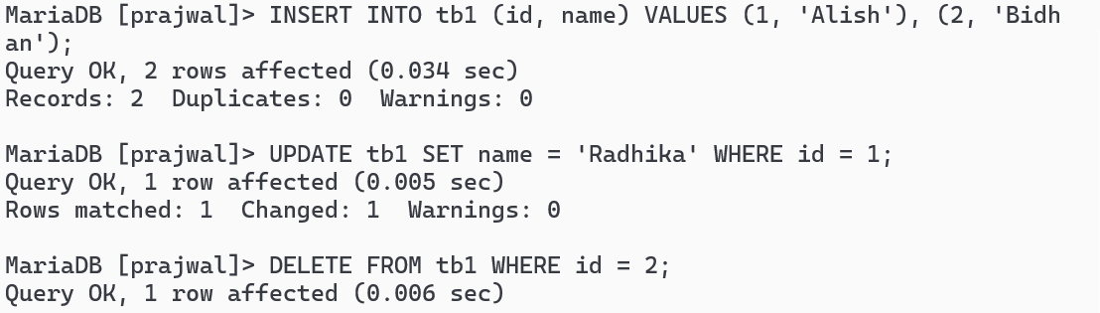
6.Exit:
Query:
REVOKE
1.Login as root user:
Query:

2.REVOKE Privileges to user <yourname> to existing databases and exit
a. REVOKE ALL PRIVILEGES ON prajwal* FROM prajwal@localhost;
Query:

3.Login as <yourname> user:
Query:

4.Check Databases:
Query:
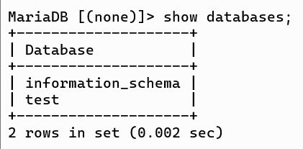
5. Exit:
Query:


